3.2 Create a New Jenkins Build Project



This section will guide you to:

* Setup Jenkins in Windows 10
* Setup a Angular Build Project in Jenkins

This guide has three subsections, namely:

3.2.1 Logging into Jenkins dashboard

3.2.2 Create Angular project and push this project in your own remote repository in GitHub.

3.2.2 Setting up a Angular Build Project in Jenkins

3.2.3 Pushing the code to your GitHub repositories

* Jenkins is installed in your practice lab. Refer to **DotNet Lab guide: Phase 4** for more information.

**Step 3.2.1:** Logging into Jenkins dashboard

* Navigate to **localhost:8080** in your browser**.**
* Enter your username and password and click on **login.**

**Step 3.2.2:** Logging into Jenkins dashboard

* Create the angular project in virtual lab.
* Open the project in VS Code
* Now move inside a project and open this project in VS Code
* Open the app-component.html page and write the code as

“Welcome to Angular project build with CI and CD tool”;

* Now push this project in your remote repository

**Step 3.2.2:** Setting up an ANGULAR Build Project in Jenkins

* Open Jenkins dashboard page on <http://localhost:8080> in your browser.
* Login as admin user.
* Go back to the Dashboard page.
* Click on Manage Jenkin

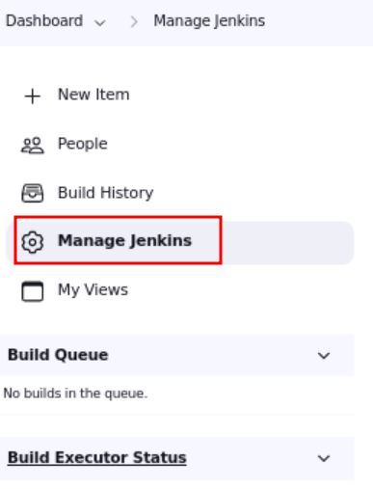

* Global tool configuration

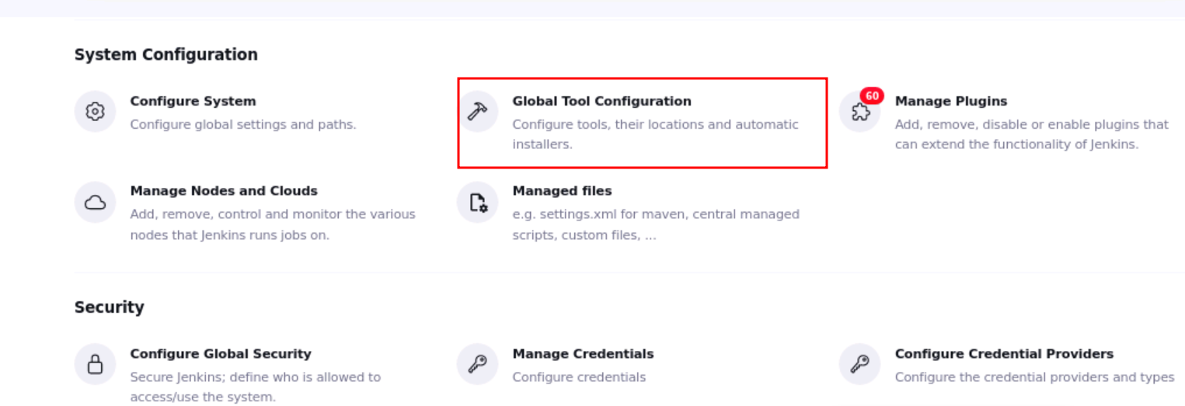

* Search the option as Node JS

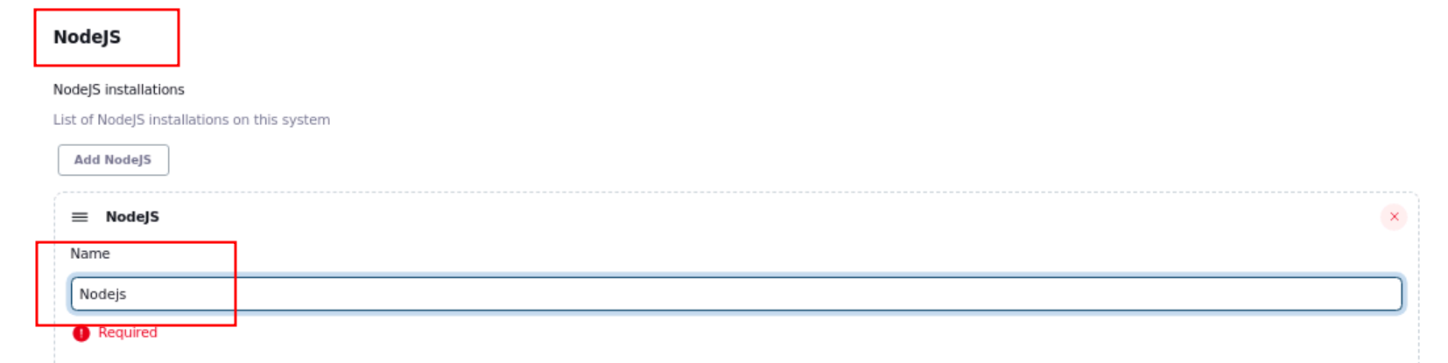

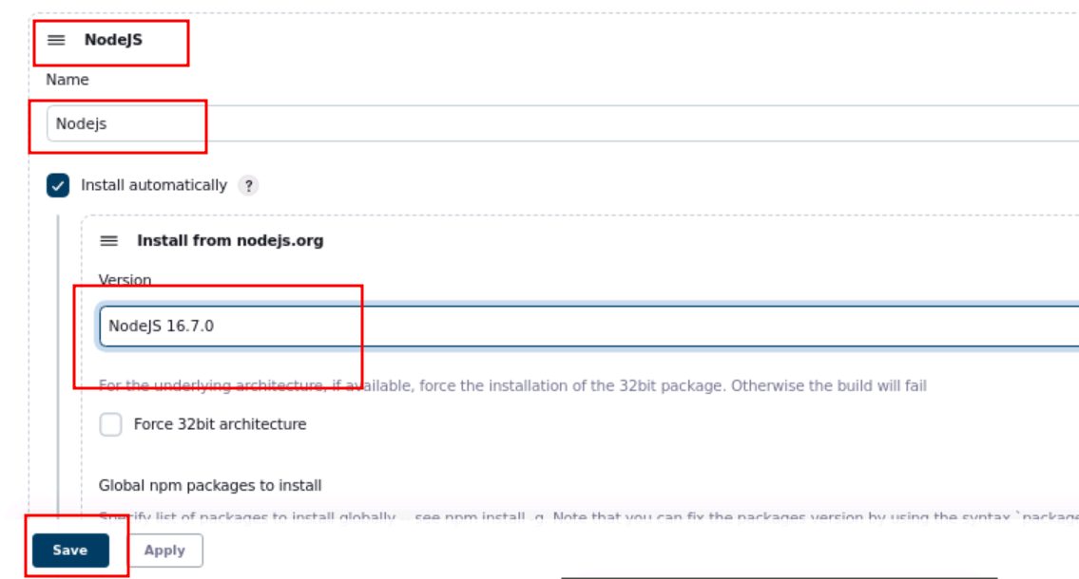

* Here Node JS added in build environment.
* In the Dashboard page, click on **New Item** from the left bar.

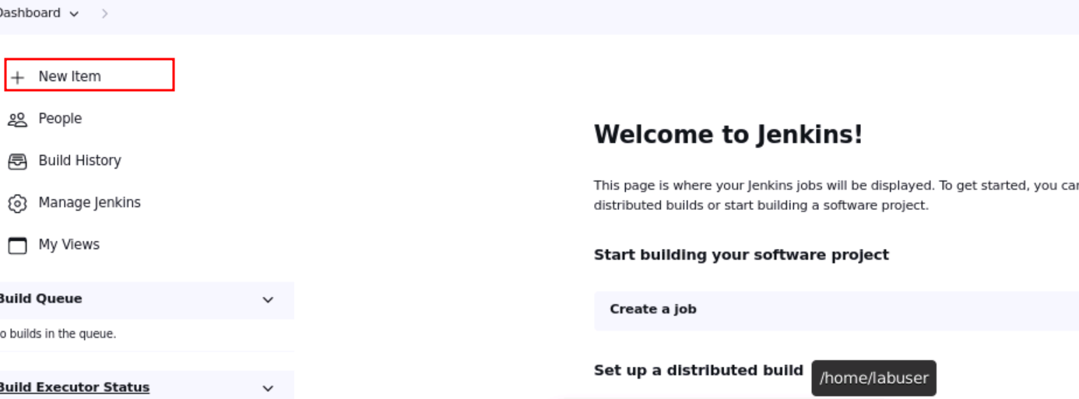

* Enter name as angular_build, select **FreeStyle Project** and **c**lick **Ok.**

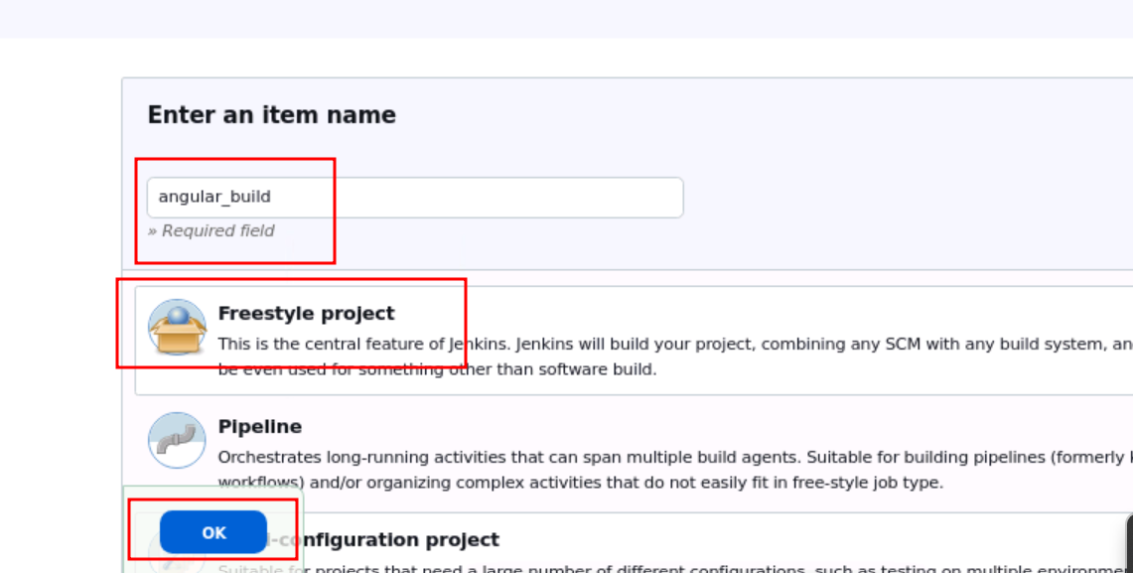

* This will open the Configuration screen.

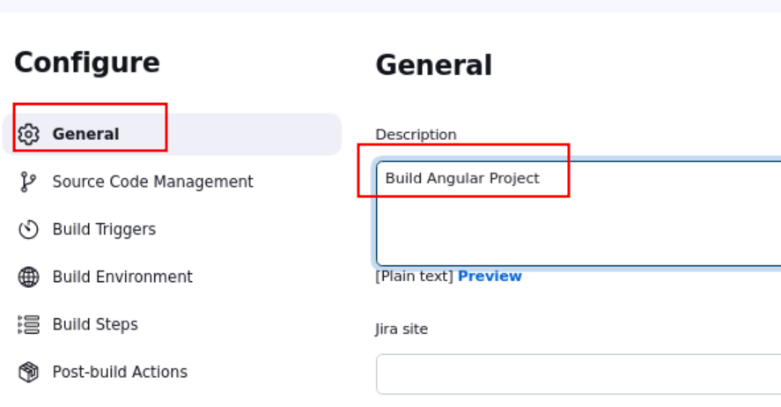

* In the **General** tab enter a description of your choice**.**
* Open Remote Git hub account and copy Remote GIT URL

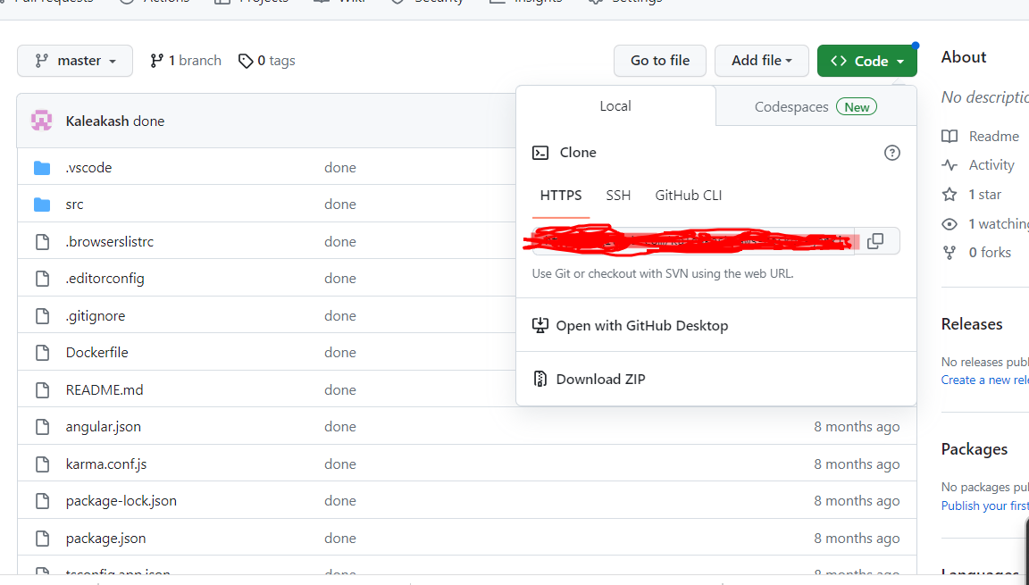

* Click **Source Code Management** tab in CI and CD account.
* Please write your GIT URL which contains Angular Project.

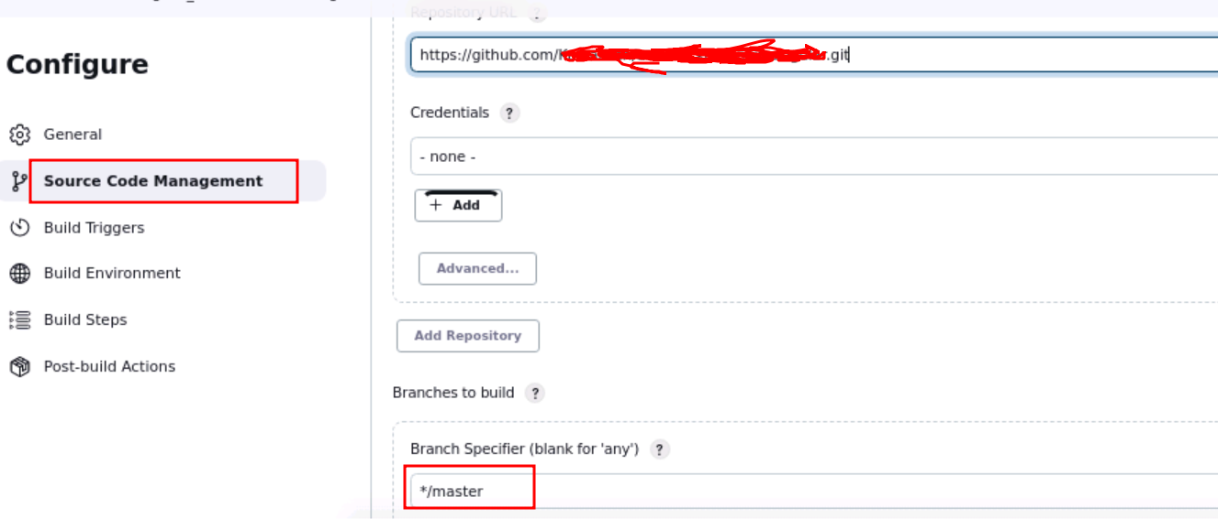

* Make sure Git branch name and this branch must be match ie master or main
* Click the **Build Environment** tab.

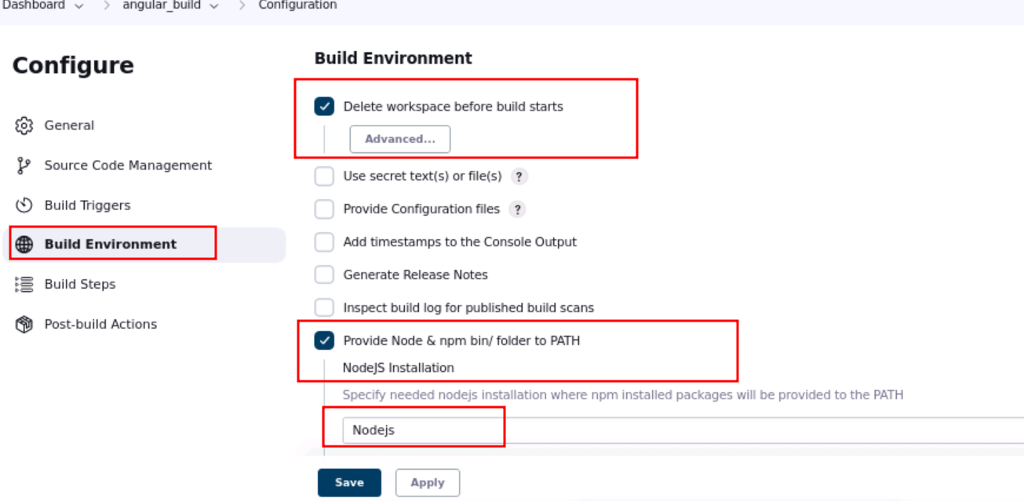

* Now click on build step option and in sub option select as window batch option

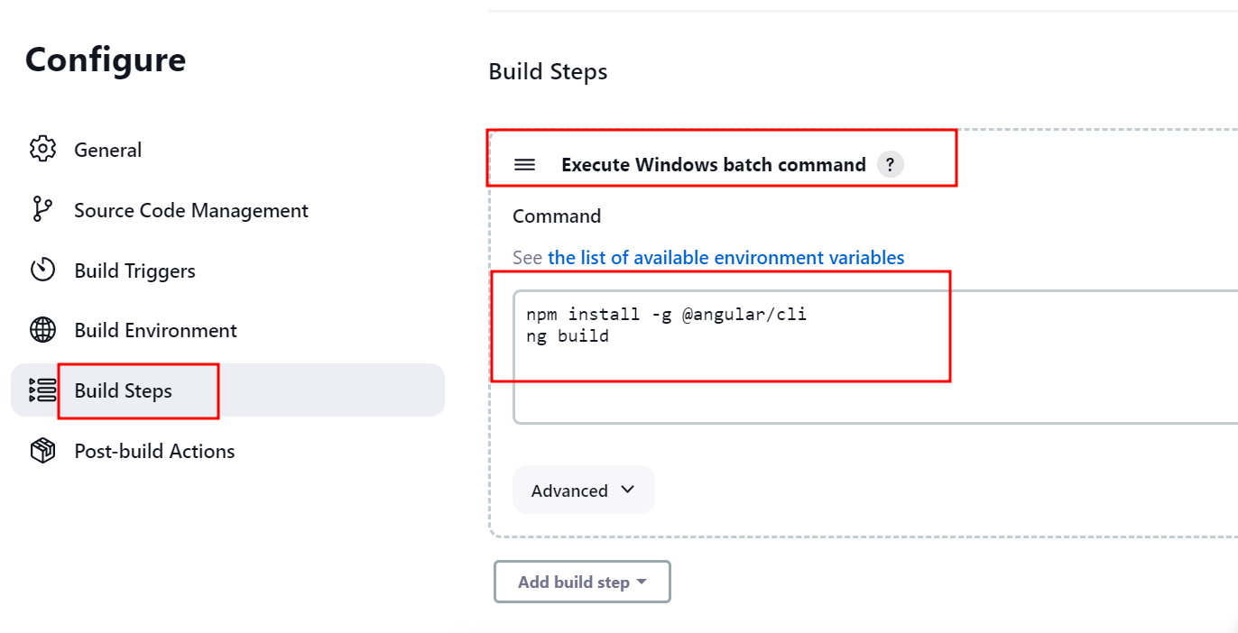

* 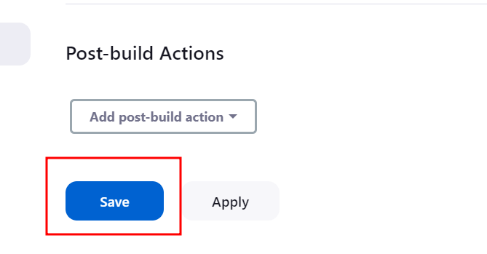
* Click **Save.**
* From the left bar, click **Build Now** to build the project. This will generate a build in the Jenkins workspace. Once the **Build Number** is displayed click on it to see the workspace.
* If error persists, you can edit the build information accordingly.

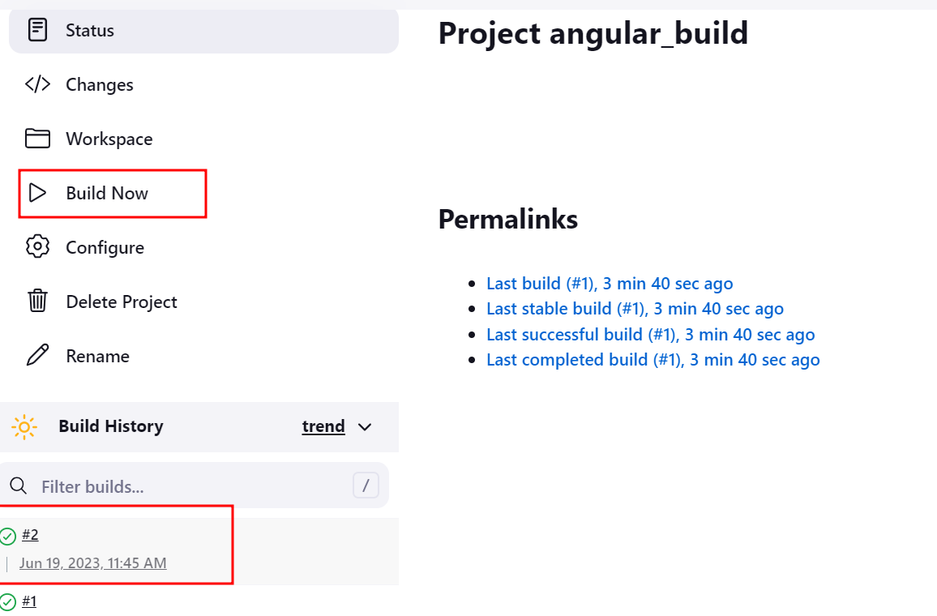

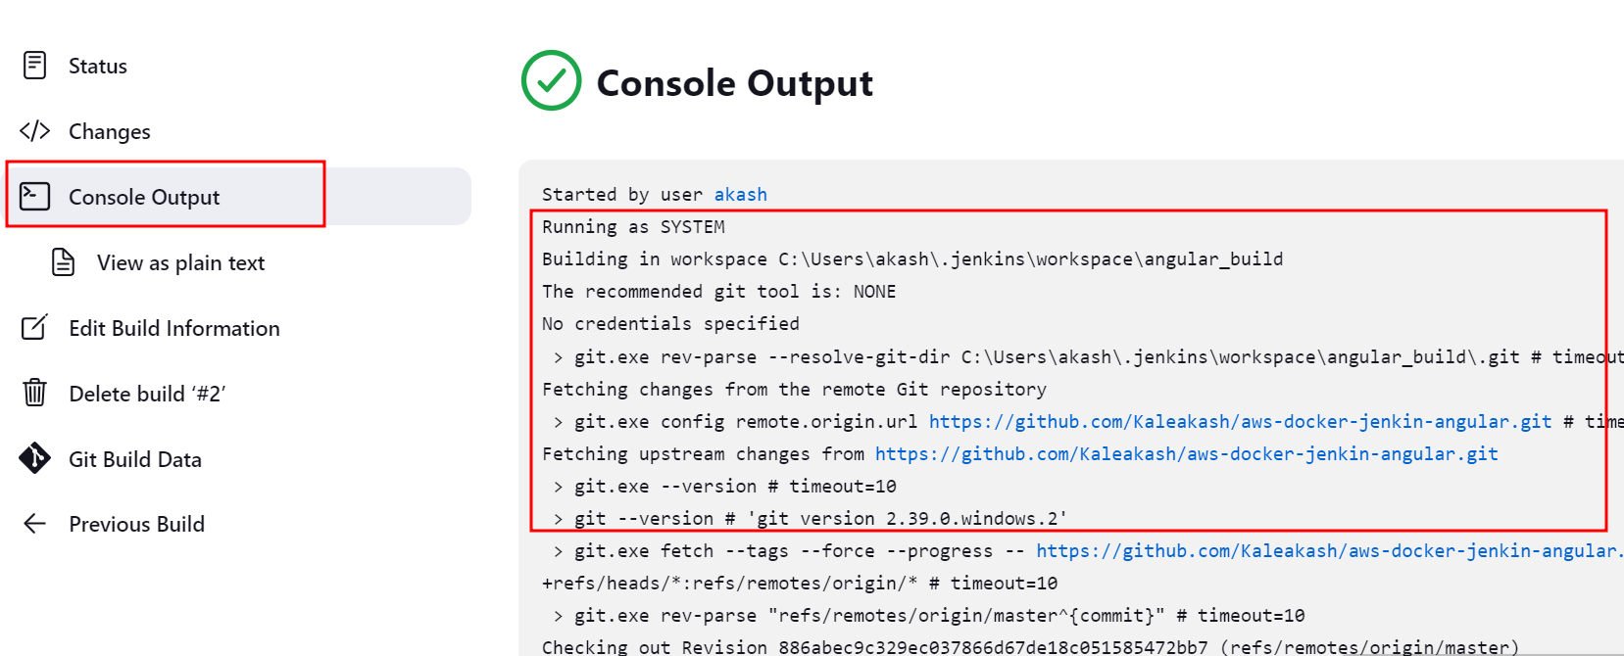

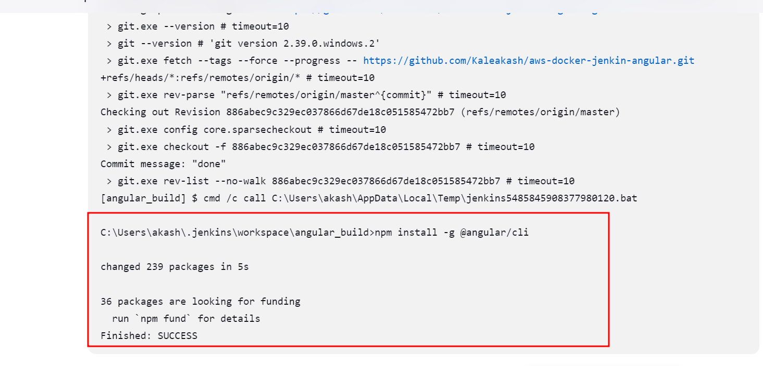

**Step 3.2.3:** Pushing the code to your GitHub repositories

Open your command prompt and navigate to the folder where you have created your files.

cd <folder path>

Initialize your repository using the following command:

git init

Add all the files to your git repository using the following command:

git add .

Commit the changes using the following command:

git commit -m “Changes have been committed.”

Push the files to the folder you created initially using the following command:

git push -u origin master